How to keep green anole lizards as classroom pets
Dr. Michele Johnson, Department of Biology, Trinity University
Summer 2013
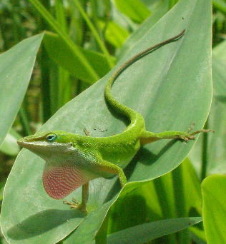
What are green anoles?
Green anoles are lizards with the scientific name Anolis carolinensis. Anoles are also sometimes known as American chameleons, although this name is misleading, as they are not actually chameleons. Green anoles occur across the southeastern United States, and San Antonio is approximately the westernmost edge of their natural range. You’ve probably seen anoles in your own backyards, likely extending their pink throat fans (dewlaps) to communicate with each other!

As their name implies, green anoles are usually green, but they can change colors between their normal bright green and a much darker brown. Scientists aren’t sure exactly why anoles change color, although color may indicate social dominance, stress, or body temperature.
Figure 1: A male green anole lizard, dewlap extended
Where do I get green anoles?
Green anoles are locally abundant in backyards and parks around San Antonio. East of San Antonio, you can find green anoles almost everywhere, but they are limited by water availability to our west. You may wish to obtain green anoles simply by catching them yourself (or asking your students to catch them). Scientists who study anoles catch them using a small slip-knot noose (usually made out of dental floss) on the end of a stick (often a fishing pole), but if you’re quick, you can also capture them by hand.

Be careful to not catch an anole by the tail. Anole tails, like those of many lizards, can be autotomized – in other words, fall off. While anoles can regrow lost tails, it requires lots of energy resources for them to do so, and if you’re left with a lizard tail in your hand, you probably don’t have the lizard! Also, anoles will often try to bite you, but they are not harmful in any way. You can blow in the lizard’s face to get it to let go of your finger.

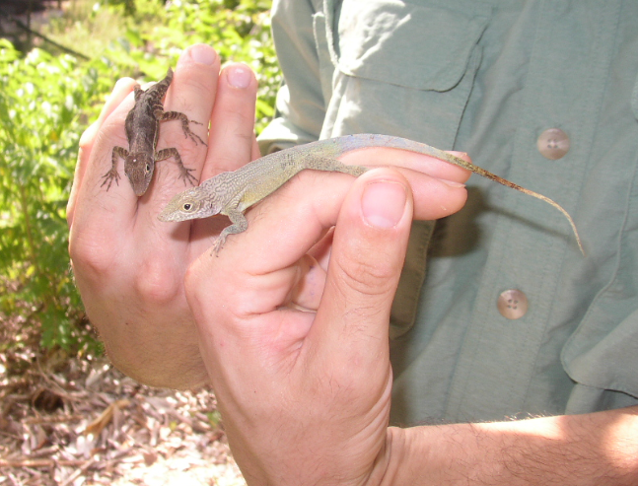
After you catch an anole, you can keep it in a plastic Tupperware container or a Ziploc bag, as long as you keep it in a cool place (OUT of direct sunlight!). These lizards have a very low metabolism rate, and the air in such a container or bag will be enough for them for a few days (if necessary), until you can get them into the cage in your classroom.

If you would prefer, you can also purchase green anoles from many pet stores (locally, PetSmart sells them), or buy them online. Prices range from $7-20 per lizard.

Note on handling anoles: Anoles will bite you or wriggle out of your hands if they are not held securely. I often hold a lizard by its hind legs (never the tail!), and I pass it from one person to another by holding onto its head (to keep it from biting the recipient). Also, lizards are ectotherms, which means they absorb heat from their environment. If they are held in human hands for long periods, they can overheat, so if a lizard has been held for a while and is panting, you should return it to its cage.
Figure 2: One way to hold a lizard

How do I house the anoles?
Anoles have few housing requirements, but they are each very important.

First, you’ll need a cage. Glass or plastic terrariums are fine. To house a single anole, a smaller cage will work, but if you want to house a male with several females, you’ll need a larger cage with room for several perches. Cages come in many varieties – you can use what is available to you, but the larger the cage, the more natural the behavior you will observe.

Second, your cage must have a lamp that provides UV light (and some heat). UV bulbs are available at pet stores and online for about $15. You can put such a bulb in any available lamp, but you will need a timer for the light ($6 at Home Depot), which should be set so that the lizard’s light is on during the same times that daylight is available outside.

Your cage will also need some kind of substrate on the bottom – you can use peat moss, rocks, sand, etc. (If you use rocks, make sure they are larger than the lizard’s mouth.) And because anoles are arboreal (tree-living) lizards, they need several perches. I like to use thicker sticks from outside, although you could purchase perches if you wanted. To keep your lizard happy, and to increase the humidity in its cage, I also recommend putting a small potted plant in the cage.

You can house multiple females (2-4) in the same cage (depending on the size of the cage), and you can house a male with a group of females, but you CANNOT house multiple males in the same cage. In fact, if you house two males such that they can even see each other, they will damage their snouts from rubbing against the cages to try to fight each other. If you have more than one male anole in your classroom, make sure there is something to block their sight from each other.
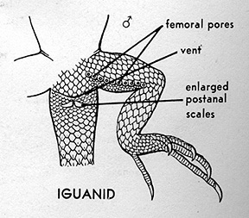
How do you tell males and females apart? If they’re adults, it’s easy – males are much larger than females, and males have the large pink dewlap (throat fan), while females have very small dewlaps. If they’re smaller lizards, it can be trickier. There are two ways that you can be absolutely sure. One is that only males will evert (stick out) their hemipenes (they have two penises) when their tails are pressed in the right way. However, knowing where to press can be difficult for a non-expert. You can also look for enlarged postanal scales just below the lizard’s vent (see the figure to the left). Males will have two scales that are much bigger than the other scales in the region; females will have only small scales. You may have to use a magnifying glass to see this clearly.
Figure 3: Enlarged postanal scales on male anole

How do I care for the anoles?
Anole care is straightforward, but as with any animal, if they do not receive the food and water they need, they will not live very long in captivity.

Anoles need water like any other pet, but they do not drink standing water. Instead, you should use a “squirt bottle” to mist them daily. Make sure to get plenty of droplets on the side of the cage and the plant inside the cage, as anoles will lick these droplets. (As an aside, if you don’t water the plant, it will die! It’s obvious, but my own students have occasionally been so focused on lizard care that they forget about the plant’s needs.) During the weekend, I wouldn’t leave the lizards without misting them for more than one day – so you may need to return to your classroom over the weekend, or take the lizards home with you.

Anoles eat live insects. Small crickets and mealworms are the best food for lizards in captivity, and these can be purchased at pet stores for very little money (crickets are usually about 10 cents each). I purchase both crickets and mealworms at Pet Supplies Plus on Austin Highway, beside the Gold’s Gym, as they have always had what I need there – larger pet stores sometimes only sell large crickets. I’ve also recently discovered Pet Frontier at 12315 Wetmore Road; (210) 653-8880 – they seem to sell everything you might need to keep lizards of any kind.

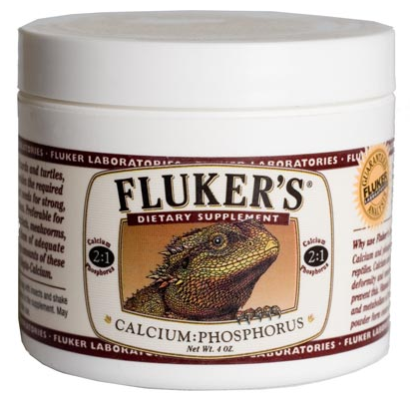
Lizards should be fed 1-2 small crickets or mealworms every 2-3 days. These insects should be coated lightly in a calcium/phosphorus powder (available at pet stores for about $5, see figure below). I put a few crickets in a dixie cup and then sprinkle them with the powder. The calcium and phosphorus are necessary to prevent the lizards from getting metabolic bone disease. Don’t leave uneaten crickets in the cage overnight. Crickets will nibble on sleeping lizards, which will obviously cause harm to the lizards.

If you buy enough crickets to feed your lizards for a week or two, you’ll also need to care for the crickets. This requires a separate cage with some toilet paper tubes or egg cartons for them to climb on, and a sponge, or an apple or potato, for them to drink from (dehydrated crickets die!). Mealworms can be purchased in small containers that come with their food, and they will remain in their larval state longer if they are kept cool (even in a refrigerator). If you want to buy lots of mealworms at one time, you can house them in a plastic container with oatmeal and/or cornmeal in the fridge. Even if you use mealworms, I recommend feeding anoles with crickets 1-2x/week, as crickets are healthier food for the lizards.
Figure 4: Calcium:phosphorus powder

If you take good care of your anoles, they may live for 1-2 years in your classroom.

Where can I get more information?
If you have questions about keeping green anoles as pets, feel free to contact Dr. Michele Johnson at Trinity University by email (michele.johnson@trinity.edu) or phone (210-999-8918). Green anoles are very popular pets, and there is also a great deal of information on the internet about how to care for them. “Pets in the Classroom” might be another useful resource, and they provide educational grants to purchase classroom supplies (http://www.petsintheclassroom.org/2011/01/pets-in-the-classroom-suggests-green-anoles/).

If you find yourself very interested in anoles, you may want to check out the Anole Annals, a blog for and by anyone interested in studying anoles (http://www.anoleannals.org). You may also consider reading Lizards in an Evolutionary Tree: Ecology and Adaptive Radiation of Anoles by Dr. Jonathan Losos, the world’s foremost anole biologist. This is a book primarily intended for biologists, but it is written in a very clear and entertaining style, and it is available at amazon.com.

